UX DESIGN PROJECT

TASK-1

Create a persona for an app that helps owner to navigate to the nearest charging station.

What features does the app need

* The user should be able to do the following key tasks, listed in order of importance:

1. Find the closest charging station.
2. See if they have enough battery to get to the charging station.

Select the type of EV vehicle they own.

* Check the competitor in the market place.
* **Select and download the program you wish to use**
  + [Sketch](https://www.sketch.com/) (this is the software that bp uses, but any of the other options can also be used to complete this task)
  + [Figma](https://www.figma.com/downloads/)
  + [Adobe XD](https://www.adobe.com/products/xd.html)
  + Any [other program](https://marketsplash.com/sketch-alternatives/) of your choosing
* **Understand the market**
  + Take some time to research EV apps and download a couple to see their features.
* **Understand personas and their role in the design process**
  + Remind yourself what a goal-directed persona is by reading a few articles like the one in the Resources section below.
* **Build your persona**
  + Use yourself as the target audience.
  + Include the following:
    - Persona name
    - Photo (any photo)
    - Demographics or Bio (gender, age, location, marital status, family)
    - Core needs
    - Frustrations (or “pain points”)
    - Behaviours
    - Bits of personality (e.g., a quote or slogan that captures the personality)

Persona Name: Alex Miller

Photo: [Insert photo of a mid-30s individual with a friendly demeanor, perhaps standing next to an electric vehicle.]

Demographics/Bio:

* Gender: Male
* Age: 35
* Location: Urban area, San Francisco Bay Area, California
* Marital Status: Married
* Family: Married with one child

Core Needs:

1. Convenient and reliable access to charging points for electric vehicles.
2. Seamless integration with personal schedule and lifestyle.
3. Cost-effective charging options to manage expenses efficiently.
4. Access to real-time information about available charging stations and their compatibility with his EV model.
5. Environmentally conscious solutions that align with his values.

Frustrations (Pain Points):

1. Limited charging options leading to range anxiety during long trips or unexpected delays.
2. Inconvenient or unreliable charging infrastructure causing disruptions in daily routines.
3. Confusion regarding charging station availability, compatibility, and pricing.
4. Concerns about the environmental impact of his transportation choices and the need for more sustainable alternatives.
5. Lack of community and social support for EV users, especially regarding shared experiences and tips.

Behaviors:

1. Regularly plans trips and schedules around charging station locations and availability.
2. Actively seeks out information about EV technology, charging options, and sustainable living practices.
3. Values efficiency and convenience in all aspects of life, including transportation.
4. Engages with online communities and forums to share experiences, tips, and recommendations related to EV usage and charging.
5. Prefers environmentally friendly products and services that align with his values and beliefs.

Bits of Personality: Quote: "Empowering my journey with sustainable solutions, one charge at a time." Slogan: "Charging Ahead, Driving Forward."

**Task2**

**UI/UX design Tasks**

### Low-fidelity wireframes

Low-fidelity wireframes usually serve as the design’s starting point. As such, they tend to be fairly rough, created without any sense of scale, grid, or pixel-accuracy.

They include only simplistic images, block shapes, and mock content—such as filler text for labels and headings.

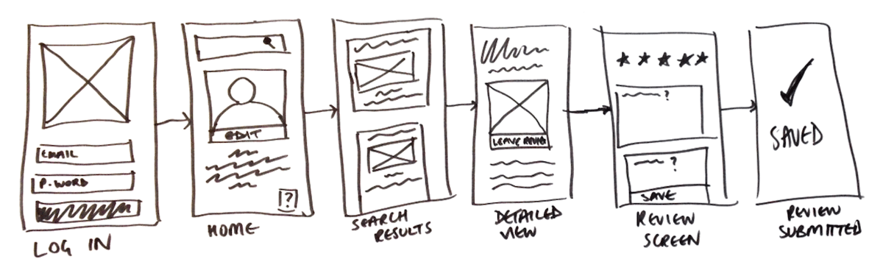

### High-fidelity wireframes

High-fidelity wireframes have pixel-specific layouts, and may include actual featured images and relevant copy.

They are ideal for exploring and documenting complex concepts such as menu systems or interactive maps.

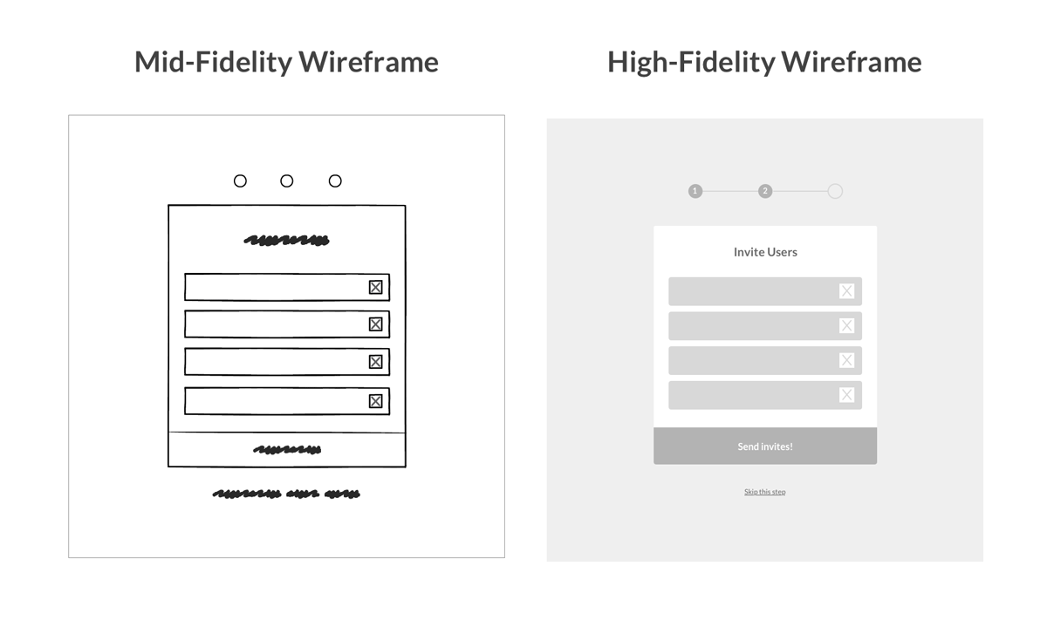

Elements that are typically found in wireframes include:

* logos
* search fields
* headers
* share buttons
* pseudo-Latin (Lorem Ipsum) placeholder text

High-fidelity wireframes may also include:

* navigation systems
* contact information
* footers

Tasks to complete

need to build low-fidelity wireframes to make your ideas into something tangible.

1. **Choose one objective to build a wireframe for:**
   1. Find the closest charging station.
   2. See if they have enough battery to get to the charging station.
   3. Select the type of EV vehicle they own.
2. **Begin wireframing the flow**

**3.Select your final flow and annotate the designs**  
Choose the flow you want to move forward with for a high-fidelity wireframe. Then, create some basic annotations so someone looking at the file will understand the basic interactions you want to achieve.

## bp Digital Design & UX Job Simulation on Forage - April 2024

* Completed a job simulation focused on developing an app for the electric vehicle industry
* Created user personas for research
* Designed basic wireframes for a mobile app
* Created prototypes for the app flow

## “Why are you interested in this role?”

I recently participated in bp's job simulation on the Forage platform, and it was incredibly useful to understand what it might be like to participate on a Digital Design team at bp.

I worked on a project to research and develop an app for the electric vehicle industry skills in a real-world context.

Doing this program confirmed that I really enjoy working on complex design projects and I'm excited to apply these skills on a Digital Design team at a company like bp.